** LEYTON SIXTH FORM COLLEGE – CENTRE NO: 13409**

**DEPARTMENT: COMPUTING AND IT**

**COURSE: BTEC EXTENDED DIPLOMA IN IT - ACADEMIC YEAR 2012-2013**

|  |  |  |  |  |  |  |  |
| --- | --- | --- | --- | --- | --- | --- | --- |
|  | | | | | | | |
| **Student Name: Student ID:** | | | | | | | |
|  | | | | | | | |
| **Unit No: 06 Unit Name: Software Design and Development**  **Internal Verifier: Date Verified:** | | | | | | | |
|  | | | | | | | |
| **Assignment No: # 1 of 3 Assignment Title: Features of Programming Languages**  **Assignment Given Out: 9th September 2013 Assignment Submission Date: 14th October 2013**  **Learning Outcome: LO1 – Know the features of programming languages.** | | | | | | | |
| **Task** | **Unit** | **Grading Criteria**  **Reference** | **Grading Criteria** | **Review Date** | **Grade Awarded** | **Date Achieved** | **Page No#** |
| 1 | 6 | P3 | explain sequence, selection and iteration as used in computer programming | 30th September 2013 |  |  |  |
| 2 | 6 | P4 | outline the benefits of having a variety of data types available to the programmer  [ | 30th September 2013 |  |  |  |
| 3 | 6 | M1 | explain the importance of the quality of code | 7th October 2013 |  |  |  |
| 3 | 6 | D1 | Discus the factors that can improve the readability of code | 7th October 2013 |  |  |  |
|  |  |  |  |  |  |  |  |
| **Assignment Rules:**  Any work submitted after the deadline may not be marked. | | | | | | | |
| **Student declaration**  I declare that all of the work submitted for this assignment is my own work or, in the case of group work, the work of myself and the other members of the group in which l have worked has not been copied from any source. I understand that if any part of the work submitted for this assignment is found to be plagiarised, none of the work submitted will be allowed to count towards the assessment of the assignment.  **Student Signature: Date:**  **Assessor Signature: Date**: | | | | | | | |

**Additional space for assessment feedback/guidance (if needed)**

|  |  |  |
| --- | --- | --- |
| **Grading Criteria reference** | **Grading criteria** | **Assessors concise and clear feedback indicating evidence to show how a criteria is being judged as being achieved or what shortfall there is to be addressed by learner and when by. (include page or any other reference)** |
| P3 | explain sequence, selection  and iteration as used in  computer programming |  |
| P4 | outline the benefits of having  a variety of data types  available to the programmer  [EP6] |  |
| M1 | explain the importance of the  quality of code |  |
| D1 | Discus the factors that can improve the readability of code |  |

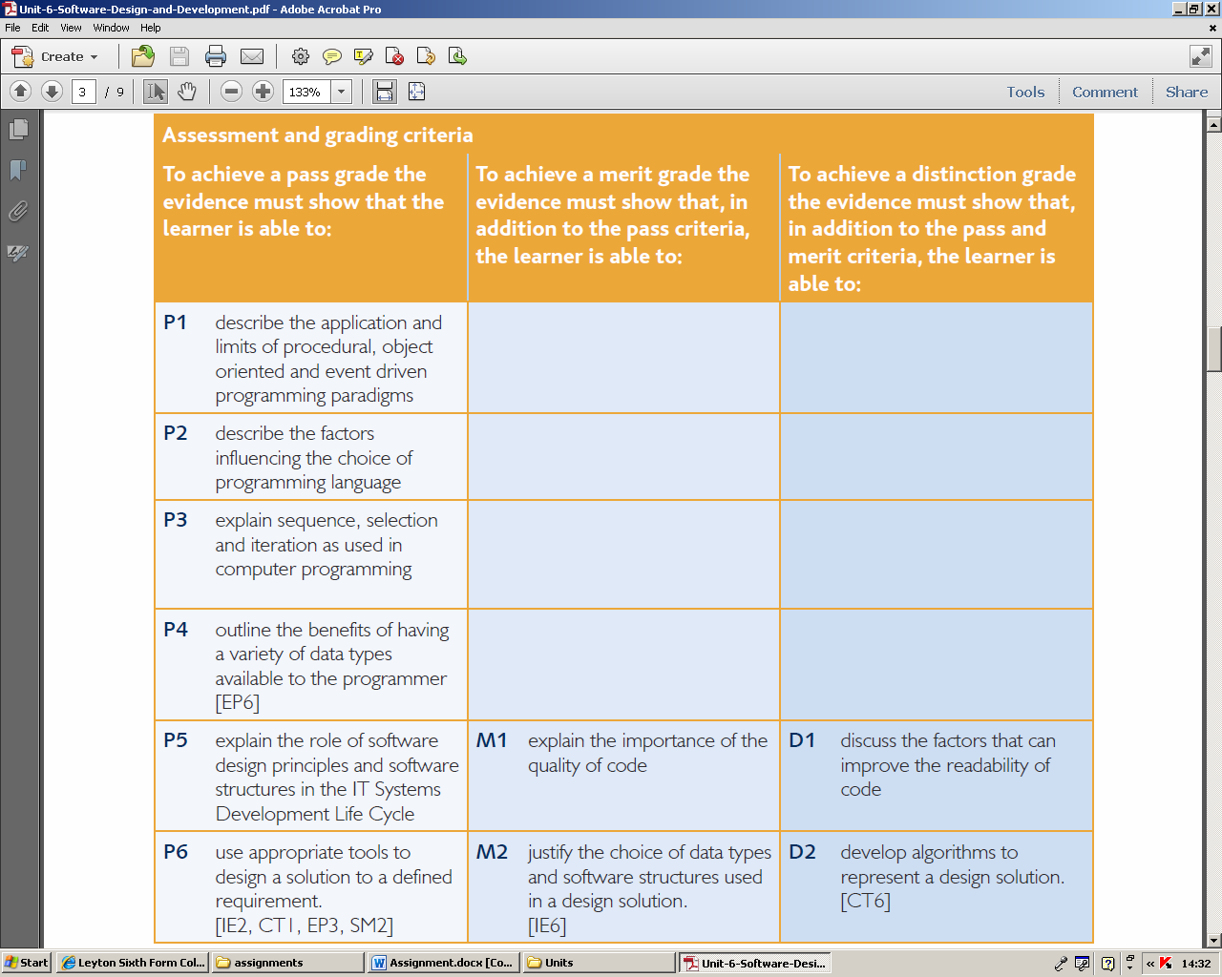

Scenario

You are employed at a small software development company in Hereford. You have been training as a programmer and the senior developer has given you a number of tasks to evaluate your understanding of software development.

**Task 1**

Produce a report explaining how sequence, selection and iteration are used when writing programs. Give examples of each and reference your images.

**(P3)**

**Task 2**

In your report explain why different data types are needed in programs and describe the benefits of having a variety of data types available to the programmer.

**(P4)**

Task 3

Amateur programmers use a range of short cuts which work fine for small programs.

However, professional programmers need to write robust, extensible and understandable code.

Create a document which explains why each of the following is important:-

* efficiency
* testing
* reliability
* robustness
* usability
* portability
* maintainability (M1)

Discuss features that can improve the readability of code.

Include in your submission references to:-

* descriptive variable names
* consistent notation
* line breaks and white space
* comments
* indentation
* segmentation

(D1)